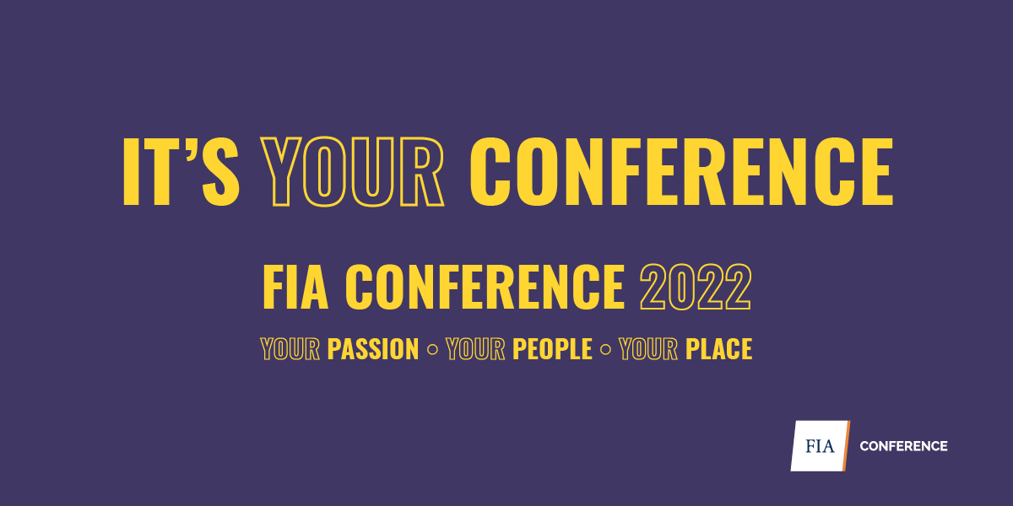
FIA Conference 2022
Custom Stand Confirmation Form
Due Date: 6 May 2022
Exhibitor: _________________________________________________________________
Stand no: _________________________________________________________________
Contact person: ____________________________________________________________
Phone: ___________________________________________________________________
Details of the contactor building your custom stand:
Contracting company: ______________________________________________________
Contact person: ___________________________________________________________
Phone: ___________________ Email: ________________________________________

What size is the footprint of the stand? _________________________________________
What is the height of the stand? ______________________________________________
Are there any double storeys? _______________________________________________
Are there any enclosed ceilings? _____________________________________________
I have included a copy of the following documents with this form:
Contractor’s public liability insurance certificates
Contractor’s WHS policies
Design details and dimensional plans of the stand

Mandatory Safety Requirements:
- A stand that has a roof or ceiling is required to provide additional fire protection equipment, such as the fitting of a smoke detector and portable CO2 or dry chemical extinguisher.
- Stands which in the opinion of ICC Sydney have significant ceilings may require a Fire Engineer sign off as nominated by the ICC Sydney at the exhibitors expense
- Where halogen tube lights are used the globe unit must be protected with safety glass to minimise the risk of explosion and fire.
- All temporary spot lights or the like are to be a minimum of 300mm from the partitions or combustible goods.
- Any custom-built stand with a floor area of more than fifty (50) square metres is to be provided with at least one (1) alternative means of egress to the walkways.
- Exit doors built into a stand need to comply with the requirements of an exit door i.e. open outwards by the use of a push bar or lever handle.
- Any door incorporated into the stand and not providing an alternate means of egress is to have a sign affixed and labelled NO THOROUGHFARE. Signs must be professionally done, not handwritten and to the satisfaction of ICC Sydney.
- Any barriers incorporated into the custom-built stand are to be designed so that they yield to pressure without toppling.
- Any double storey stands will require an Engineer Certificate prior to erection and an Engineer signoff on site once the structure is built to ensure its build is as per the original engineer’s specifications. The sign off must be completed and copies provided to ICC Sydney Management before the second level can be occupied.
- Any double storey stand as part of the Engineer Certificate will clearly define the number of occupants allowed taking into account any other item on the second storey
- The National Construction Code (NCC) requires that materials used for stand construction must comply with the Fire Hazard Properties set out in clause C1.10 of Volume 1 of the NCC.
- All custom stand design must comply with all other relevant codes of the NCC
- The maximum permissible stand height in the Gallery is 4m
Contractor Management:
Please be aware that all custom stand build contractors must register through the ICC Rapid Global Contractor Management System. Any high risk works that intend to be undertaken by contractors should submit relevant licences, qualifications and SWMS on their ICC Rapid Global profile.
For assistance send your request to inductions@iccsydney.com
PLEASE NOTE:
ICC Sydney representatives undertake regular compliance checks and you may be asked to provide evidence in relation to the above requirements. If at any time, an activity or operation is considered non-compliant, unsafe or placing persons or the environment at risk, ICC Sydney representatives have the right to postpone or cancel the activity until the issue is rectified. Understand that at any stage before or after this permit is reviewed, ICC Sydney may add or remove any restrictions to the use or application of this permit, in its sole and absolute discretion.
While care and consideration has been taken in the creation of the material on this document, we do not warrant, represent or guarantee that the material is in all respects accurate, complete and current. To the extent permitted by law, we exclude any liability, including any liability for negligence, for any loss or damage arising from reliance on material on this document.

Due Date: 6 May 2022
Return to: Natalie Walker, Executive Manager – Events
Phone: 02 9410 5902 | Email: training@fia.org.au

