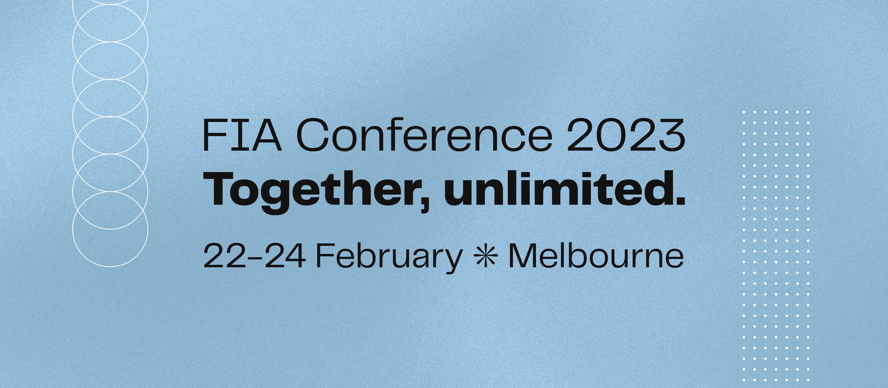

FIA Delegate Notebook

Advertising Specifications
If you have booked an advert, artwork will need to be sent to the FIA Secretariat no later than 9 December 2022 by email to lwallace@fia.org.au or nwalker@fia.org.au
Please ensure you adhere to the following specifications, otherwise your advert may not be included.

Advertisement sizes:
Cover Advert (back cover and inside front/back cover)
210mm (deep) x 148mm (wide)
5mm bleed on all sides with trim marks

Full-Page Colour Advert
210mm (deep) x 148mm (wide)
5mm bleed on all sides with trim marks

Half-Page Colour Advert (horizontal)
105mm (deep) x 148mm (wide)
5mm bleed on all sides with trim marks

All images 300dpi at size – HiRes, Press Quality PDF with all fonts embedded for the final supplied document. All artwork converted to CMYK.

If you have any questions or require any further information, please do not hesitate to contact Lindsay or Natalie on 02 9411 6644

