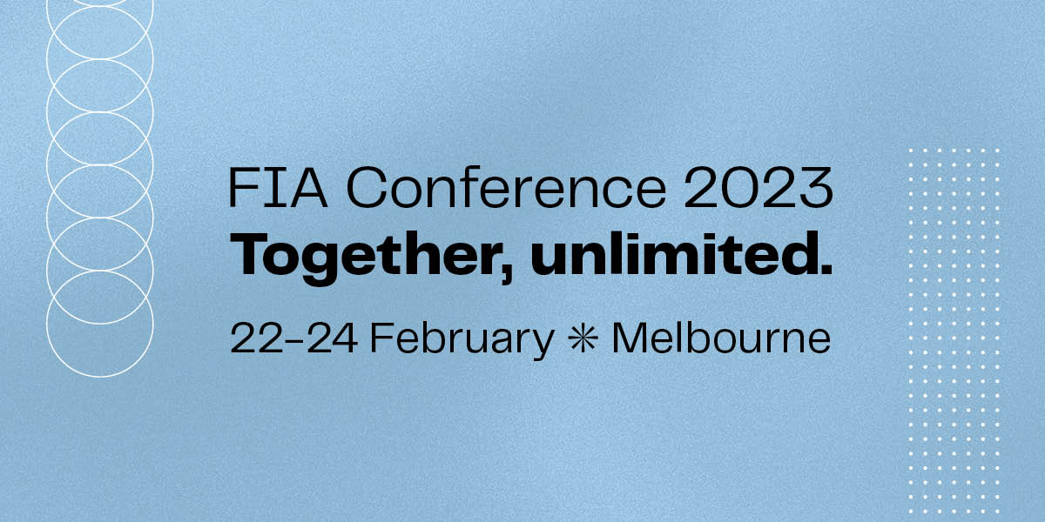
FIA Conference 2023
Sponsor/Exhibitor Information Form
Due: 9 December 2022

Company: ________________________________________ Stand no: __________
Exhibitor Name (if different from company name): ____________________________
____________________________________________________________________

Contact details (not for publishing)
Contact person: ______________________________________________________
Phone: __________________________ Mobile: _____________________________
Email: ______________________________________________________________

Contact details to be published on the website and conference app
Contact person (if applicable): __________________________________________
Phone: ___________________ Email: _____________________________________
Website: ____________________________________________________________

Stand details
Shell scheme (stand to include walling, carpet, power, lighting)
Space only / Custom Stand (carpet only)
* Please also complete the Custom Stand Confirmation Form – this will be available with the exhibition manual.
Company profile
Please include a 200-word company profile to be published on the conference website and conference app as well as any social media handles you would like to promote.

Email to: Lwallace@fia.org.au along with a high-res JPEG or EPS logo.

Return to:
Lindsay Wallace | Manager Event & Sponsorship
Email: Lwallace@fia.org.au
Phone: 02 9411 6644

